DAA Lab Report - Lab 3
Smart Resource Allocation and Scheduling System using Greedy Algorithms
Field | Details
Name | Tamanna
Roll No. | 2401201138
Course | BCA(AI & DS)
Section | A
Lab Name | Lab 3 - Smart Resource Allocation and Scheduling System using Greedy Algorithms

Problem Statement
Develop a Smart Resource Allocation and Scheduling System using Greedy Algorithms to solve real-world optimization problems. The system implements Fractional Knapsack (resource allocation), Activity Selection (task scheduling) and Huffman Coding (data compression), generates optimal solutions, analyses performance and presents results through visualizations and complexity comparisons.

Question 1: Project Workspace Setup
Create a GitHub repository, virtual environment and install the required libraries.
mkdir daa_lab3 && cd daa_lab3
git init
python -m venv venv
source venv/bin/activate # On Windows: venv\Scripts\activate
pip install numpy matplotlib pandas jupyter

Question 2: Resource Allocation Module (Fractional Knapsack)
Sort items by value/weight ratio in descending order and take items greedily; the last item may be taken fractionally. Time O(n log n), space O(n).
Output:

Maximum achievable value: 240.0
Gold: 100.0% taken
Silver: 100.0% taken
Bronze: 66.7% taken
Result: Gold 100%, Silver 100%, Bronze 66.7% are taken; maximum profit = 240.

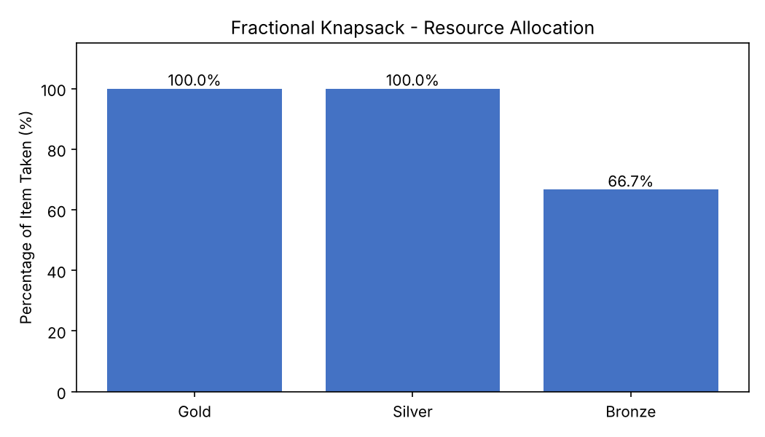
Figure 1: Resource allocation chart

Question 3: Task Scheduling Module (Activity Selection)
Sort activities by finish time and select each activity whose start time is at least the finish time of the last selected one. Time O(n log n), space O(n).
Output:
Selected activities:
A1: [1, 4]
A4: [5, 7]
A8: [8, 11]
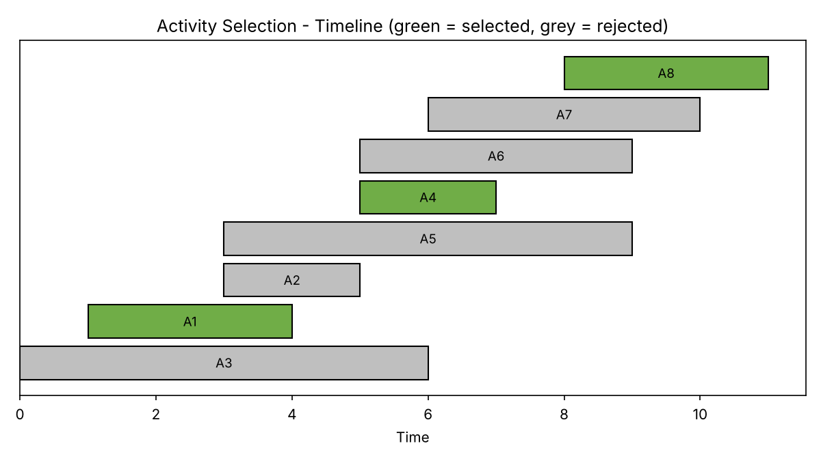
Figure 2: Activity timeline

Question 4: Data Compression Module (Huffman Coding)
A min-heap repeatedly merges the two least frequent nodes; codes are read by traversing the tree (0 = left, 1 = right). Time O(n log n) for n distinct characters, space O(n).
Output:
Huffman codes: {'a': '0', 'd': '100', 'c': '101', 'r': '110', 'b': '111'}
Encoded bits : 01111100101010001111100
Original size: 88 bits, Compressed size: 23 bits
Compression ratio: 26.14%

Compression statistics: original 88 bits, compressed 23 bits, compression ratio 26.14% (about 73.9% space saved).
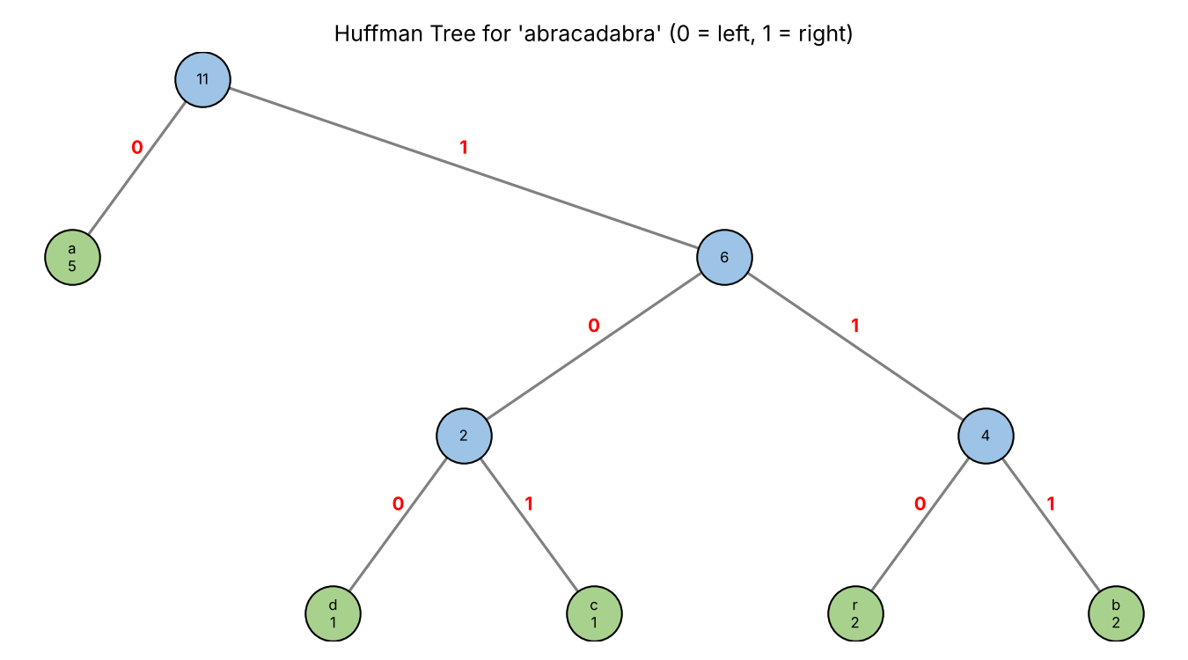
Figure 3: Huffman tree for 'abracadabra'

Question 5: Execution Time, Memory and Complexity Comparison
n | Knapsack Time (ms) | Knapsack Mem (KB) | Activity Time (ms) | Activity Mem (KB) | Huffman Time (ms) | Huffman Mem (KB)
100 | 0.017 | 1.4 | 0.009 | 1.9 | 0.024 | 8.4
500 | 0.094 | 21.3 | 0.056 | 11.9 | 0.041 | 13.8
1000 | 0.215 | 44.7 | 0.169 | 23.6 | 0.076 | 20.7
5000 | 1.953 | 231.9 | 1.387 | 117.1 | 0.288 | 72.2
10000 | 4.165 | 466.6 | 4.036 | 234.6 | 0.845 | 138.5
20000 | 9.062 | 935.4 | 9.349 | 468.9 | 1.368 | 270.8
50000 | 22.404 | 2341.5 | 19.459 | 1171.9 | 3.185 | 675.4

Algorithm | Time Complexity | Space Complexity | Dominant Step
Fractional Knapsack | O(n log n) | O(n) | Sorting items by value/weight ratio
Activity Selection | O(n log n) | O(n) | Sorting activities by finish time
Huffman Coding | O(n log n) | O(n) | n-1 heap operations, each O(log n) (n = distinct characters)

Question 6: Visualizations and Performance Graphs
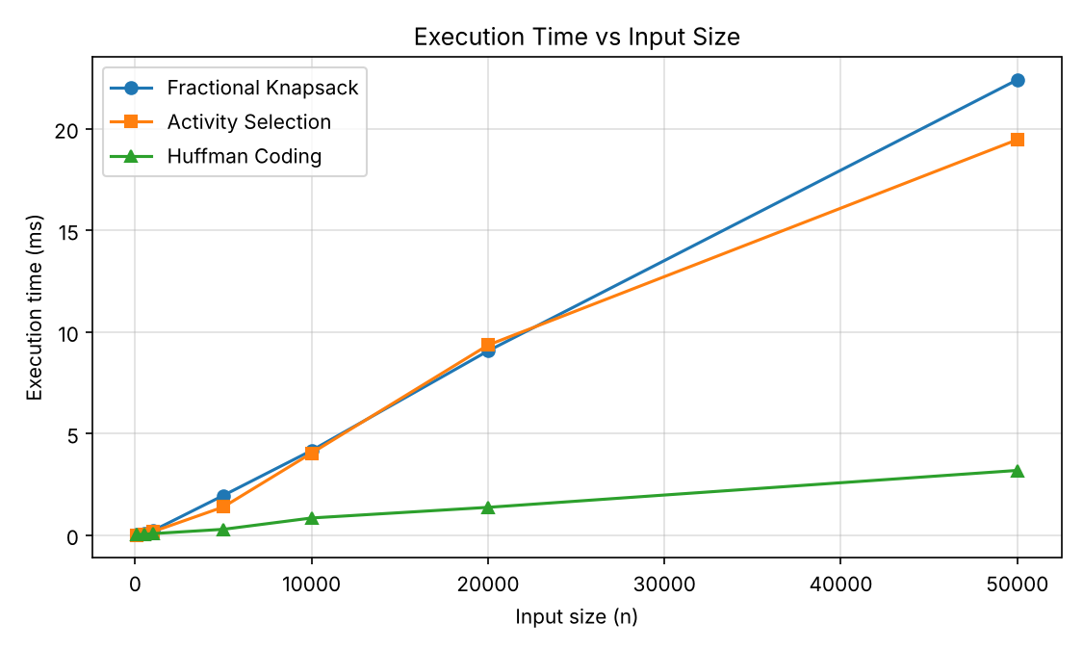
Figure 4: Execution time vs input size
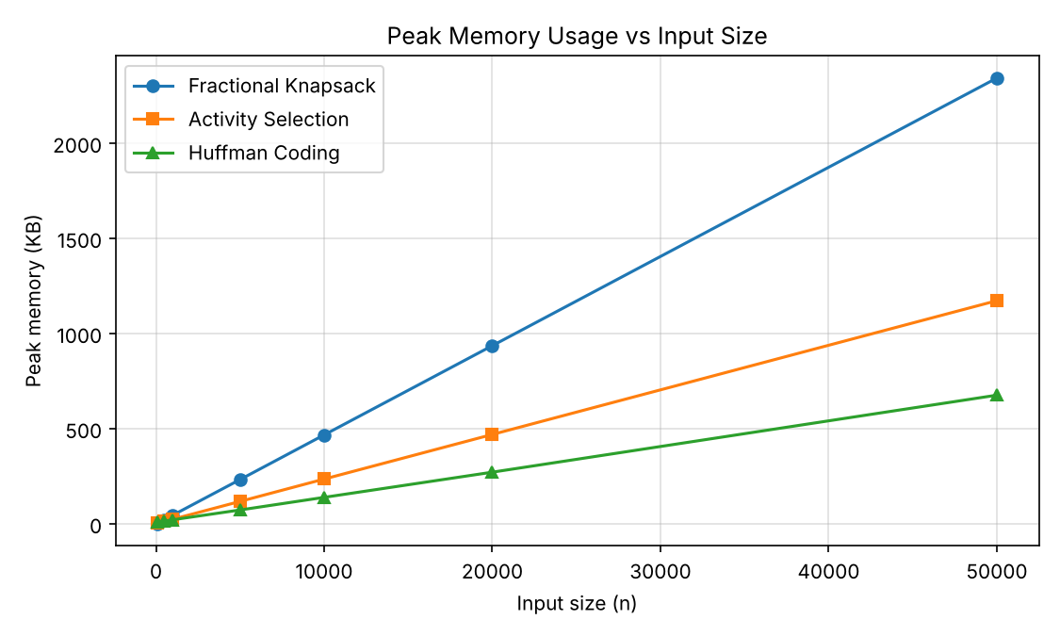
Figure 5: Peak memory vs input size

Question 7: Discussion and Key Observations

Why the greedy choice is optimal
- Fractional Knapsack: by an exchange argument, if an optimal solution uses a lower-ratio item while part of a higher-ratio item is left out, swapping weight to the higher-ratio item never reduces the value. So taking the highest ratio first is optimal.
- Activity Selection: the activity that finishes earliest leaves the most time for the remaining ones; any optimal schedule can swap its first activity for the earliest-finishing one without losing any activity.
- Huffman Coding: the two least frequent symbols can always be placed as deepest sibling leaves in an optimal prefix code, so merging them first is safe and gives the minimum total encoded length.

Practical applications
- Resource budgeting and cargo/load distribution (Fractional Knapsack).
- CPU job scheduling and classroom/meeting-room booking (Activity Selection).
- File compression: ZIP (DEFLATE) and JPEG use Huffman-style coding.

Complexity and timing
All three algorithms run in O(n log n) time and O(n) space. The experiments confirm that even 50,000 inputs are processed in a few milliseconds. Huffman was fastest here because its heap size depends only on the number of distinct characters.

When greedy fails
Greedy is not always optimal. In the 0/1 Knapsack problem, items cannot be split, so picking by best ratio can give a worse answer than the true optimum; Dynamic Programming (Lab 4) is needed there.

Complete Source Code
"""Lab 3: Smart Resource Allocation and Scheduling System using Greedy Algorithms
Modules: Fractional Knapsack, Activity Selection, Huffman Coding + performance + plots
"""
import heapq
import random
import string
import time
import tracemalloc
from collections import Counter

import matplotlib
matplotlib.use("Agg")
import matplotlib.pyplot as plt

# ---------------- Q2: Fractional Knapsack ----------------
def fractional_knapsack(items, capacity):
sorted_items = sorted(items, key=lambda x: x["value"] / x["weight"], reverse=True)
total_value, chosen, remaining = 0.0, [], capacity
for item in sorted_items:
if remaining <= 0:
break
if item["weight"] <= remaining:
total_value += item["value"]
remaining -= item["weight"]
chosen.append((item["name"], 1.0))
else:
fraction = remaining / item["weight"]
total_value += item["value"] * fraction
chosen.append((item["name"], fraction))
remaining = 0
return total_value, chosen

# ---------------- Q3: Activity Selection ----------------
def activity_selection(activities):
sorted_acts = sorted(activities, key=lambda a: a["finish"])
selected = [sorted_acts[0]]
last_finish = sorted_acts[0]["finish"]
for act in sorted_acts[1:]:
if act["start"] >= last_finish:
selected.append(act)
last_finish = act["finish"]
return selected

# ---------------- Q4: Huffman Coding ----------------
class Node:
def __init__(self, char, freq, left=None, right=None):
self.char, self.freq, self.left, self.right = char, freq, left, right

def __lt__(self, other):
return self.freq < other.freq

def build_huffman_tree(text):
frequency = Counter(text)
heap = [Node(ch, f) for ch, f in frequency.items()]
heapq.heapify(heap)
while len(heap) > 1:
left = heapq.heappop(heap)
right = heapq.heappop(heap)
heapq.heappush(heap, Node(None, left.freq + right.freq, left, right))
return heap[0]

def generate_codes(node, prefix="", codebook=None):
if codebook is None:
codebook = {}
if node is None:
return codebook
if node.char is not None:
codebook[node.char] = prefix or "0"
return codebook
generate_codes(node.left, prefix + "0", codebook)
generate_codes(node.right, prefix + "1", codebook)
return codebook

def huffman_encode(text):
root = build_huffman_tree(text)
codebook = generate_codes(root)
encoded = "".join(codebook[ch] for ch in text)
return encoded, codebook

# ---------------- Q6: Visualizations ----------------
def plot_knapsack_allocation(selection, path):
names = [s[0] for s in selection]
fractions = [s[1] * 100 for s in selection]
plt.figure(figsize=(7, 4))
bars = plt.bar(names, fractions, color="#4472C4")
for b, f in zip(bars, fractions):
plt.text(b.get_x() + b.get_width() / 2, f + 1, f"{f:.1f}%", ha="center")
plt.ylabel("Percentage of Item Taken (%)")
plt.ylim(0, 115)
plt.title("Fractional Knapsack - Resource Allocation")
plt.tight_layout()
plt.savefig(path, dpi=150)
plt.close()

def plot_activity_timeline(all_acts, selected, path):
sel_names = {a["name"] for a in selected}
acts = sorted(all_acts, key=lambda a: a["start"])
plt.figure(figsize=(8, 4.5))
for i, act in enumerate(acts):
chosen = act["name"] in sel_names
plt.barh(i, act["finish"] - act["start"], left=act["start"],
color="#70AD47" if chosen else "#BFBFBF", edgecolor="black")
plt.text(act["start"] + (act["finish"] - act["start"]) / 2, i, act["name"],
va="center", ha="center", fontsize=9)
plt.xlabel("Time")
plt.yticks([])
plt.title("Activity Selection - Timeline (green = selected, grey = rejected)")
plt.tight_layout()
plt.savefig(path, dpi=150)
plt.close()

def _layout(node, depth, x, pos):
"""Assign (x, y) positions with in-order x so the tree does not overlap."""
if node is None:
return x
x = _layout(node.left, depth + 1, x, pos)
pos[id(node)] = (x, -depth)
x += 1
x = _layout(node.right, depth + 1, x, pos)
return x

def plot_huffman_tree(root, path):
pos = {}
_layout(root, 0, 0, pos)
plt.figure(figsize=(9, 5))

def draw(node):
if node is None:
return
x, y = pos[id(node)]
for child, bit in ((node.left, "0"), (node.right, "1")):
if child is not None:
cx, cy = pos[id(child)]
plt.plot([x, cx], [y, cy], color="gray", zorder=1)
plt.text((x + cx) / 2, (y + cy) / 2 + 0.08, bit, color="red",
fontsize=10, ha="center", fontweight="bold")
draw(child)
label = f"{node.char}\n{node.freq}" if node.char is not None else str(node.freq)
color = "#A9D18E" if node.char is not None else "#9DC3E6"
plt.scatter([x], [y], s=900, color=color, edgecolor="black", zorder=2)
plt.text(x, y, label, ha="center", va="center", fontsize=8, zorder=3)

draw(root)
plt.axis("off")
plt.title("Huffman Tree for 'abracadabra' (0 = left, 1 = right)")
plt.tight_layout()
plt.savefig(path, dpi=150)
plt.close()

# ---------------- Q5: Performance measurement ----------------
def measure(func, *args, repeats=5):
best = float("inf")
for _ in range(repeats):
t = time.perf_counter()
func(*args)
best = min(best, time.perf_counter() - t)
tracemalloc.start()
func(*args)
_, peak = tracemalloc.get_traced_memory()
tracemalloc.stop()
return best, peak / 1024 # seconds, KB

def gen_items(n):
return [{"name": f"I{i}", "weight": random.randint(1, 100),
"value": random.randint(1, 500)} for i in range(n)]

def gen_acts(n):
out = []
for i in range(n):
s = random.randint(0, n * 5)
out.append({"name": f"A{i}", "start": s, "finish": s + random.randint(1, 20)})
return out

def gen_text(n):
return "".join(random.choices(string.ascii_lowercase, k=n))

def run_experiments(sizes):
random.seed(7)
rows = []
for n in sizes:
items, acts, text = gen_items(n), gen_acts(n), gen_text(n)
cap = sum(i["weight"] for i in items) // 2
tk, mk = measure(fractional_knapsack, items, cap)
ta, ma = measure(activity_selection, acts)
th, mh = measure(huffman_encode, text)
rows.append({"n": n, "knap_t": tk, "knap_m": mk, "act_t": ta, "act_m": ma,
"huf_t": th, "huf_m": mh})
return rows

def plot_performance(rows, time_path, mem_path):
ns = [r["n"] for r in rows]
plt.figure(figsize=(7.5, 4.5))
plt.plot(ns, [r["knap_t"] * 1000 for r in rows], marker="o", label="Fractional Knapsack")
plt.plot(ns, [r["act_t"] * 1000 for r in rows], marker="s", label="Activity Selection")
plt.plot(ns, [r["huf_t"] * 1000 for r in rows], marker="^", label="Huffman Coding")
plt.xlabel("Input size (n)")
plt.ylabel("Execution time (ms)")
plt.title("Execution Time vs Input Size")
plt.grid(True, alpha=0.4)
plt.legend()
plt.tight_layout()
plt.savefig(time_path, dpi=150)
plt.close()

plt.figure(figsize=(7.5, 4.5))
plt.plot(ns, [r["knap_m"] for r in rows], marker="o", label="Fractional Knapsack")
plt.plot(ns, [r["act_m"] for r in rows], marker="s", label="Activity Selection")
plt.plot(ns, [r["huf_m"] for r in rows], marker="^", label="Huffman Coding")
plt.xlabel("Input size (n)")
plt.ylabel("Peak memory (KB)")
plt.title("Peak Memory Usage vs Input Size")
plt.grid(True, alpha=0.4)
plt.legend()
plt.tight_layout()
plt.savefig(mem_path, dpi=150)
plt.close()

if __name__ == "__main__":
import json
out = "/tmp/outputs"
results = {}

# Q2
items = [{"name": "Gold", "weight": 10, "value": 60},
{"name": "Silver", "weight": 20, "value": 100},
{"name": "Bronze", "weight": 30, "value": 120}]
value, selection = fractional_knapsack(items, 50)
print("Maximum achievable value:", value)
for name, frac in selection:
print(f" {name}: {frac * 100:.1f}% taken")
results["knap"] = {"value": value, "sel": selection}
plot_knapsack_allocation(selection, f"{out}/knapsack_allocation.png")

# Q3
activities = [{"name": "A1", "start": 1, "finish": 4}, {"name": "A2", "start": 3, "finish": 5},
{"name": "A3", "start": 0, "finish": 6}, {"name": "A4", "start": 5, "finish": 7},
{"name": "A5", "start": 3, "finish": 9}, {"name": "A6", "start": 5, "finish": 9},
{"name": "A7", "start": 6, "finish": 10}, {"name": "A8", "start": 8, "finish": 11}]
result = activity_selection(activities)
print("Selected activities:")
for a in result:
print(f" {a['name']}: [{a['start']}, {a['finish']}]")
results["act"] = [(a["name"], a["start"], a["finish"]) for a in result]
plot_activity_timeline(activities, result, f"{out}/activity_timeline.png")

# Q4
text = "abracadabra"
encoded, codebook = huffman_encode(text)
print("Huffman codes:", codebook)
print("Encoded bits :", encoded)
ob = len(text) * 8
print(f"Original size: {ob} bits, Compressed size: {len(encoded)} bits")
print(f"Compression ratio: {len(encoded) / ob:.2%}")
results["huf"] = {"codes": codebook, "encoded": encoded, "orig": ob, "comp": len(encoded)}
plot_huffman_tree(build_huffman_tree(text), f"{out}/huffman_tree.png")

# Q5 / Q6 performance
rows = run_experiments([100, 500, 1000, 5000, 10000, 20000, 50000])
print("\n n | knap ms/KB | act ms/KB | huffman ms/KB")
for r in rows:
print(f"{r['n']:>6} | {r['knap_t']*1000:.3f}/{r['knap_m']:.1f} | "
f"{r['act_t']*1000:.3f}/{r['act_m']:.1f} | {r['huf_t']*1000:.3f}/{r['huf_m']:.1f}")
results["rows"] = rows
plot_performance(rows, f"{out}/performance_time.png", f"{out}/performance_memory.png")
json.dump(results, open(f"{out}/results.json", "w"), indent=1)

Screenshots

GitHub Link

